PLEASE READ
2017 Tennis AGM

Warwick Boat Club clubhouse; Wednesday November 8th 2017
- Registration opens at 6:30pm
- Meeting starts at 7:00pm
- Meeting closes at about 8:30pm when Voting is complete
- Bar open, and food available as usual for Wednesday night Mix-In
- Meeting Quorum of 20 people is required

Agenda
- Review and approval of 2016 Tennis AGM minutes
- Tennis Report: 2017 in Review
- Election of the 2018 Tennis Committee
- Any other business (no formal resolutions have been received)

Electing the 2018 Tennis Committee
- List of Nominees published at WBC and emailed to Members
- Vote online, by proxy, or in-person
- For online voting, please check your email from the Club for instructions.
- For proxy voting, please see forms attached to the Tennis Notice board.

Summary of Tennis Committee 2018 Nominations
Please vote for the Team Tennis & Social Tennis Leads!
Tennis Committee Role | Candidate | Proposer | Seconder
- Tennis Captain | Paul Martin | Steve Chidlow | Geoff Sault
- Membership, People & Welfare | Graham Kensett | Don Clark | James Francombe
- Finance, Legal & Commercial | Nick Peall | Owen Watson | Paul Martin
- Marketing & PR | Graham Harrington | Geoff Prince | Paul Martin
- Facilities & Development | Geoff Prince | Paul Martin | Owen Watson
- Team Tennis | - Don Clark  - Jackie Robinson | - Graham Kensett  - Jenny Waggott | - Steve Chidlow  - Susie Rowe
- Social Tennis | - Daryl Howe  - Trix Law | - Jane Robbins  - Philip Purcell | - Phil Allen  - Sue Woodward
- Events | No Nominations
- Secretary | No Nominations

Notice to Members:
- Requirements of each role are contained in the Tennis Section Constitution.
- Where only one nomination has been received, the nominee will be elected to the position unopposed.
- Where more than one nomination has been received, the membership vote will determine which nominee joins the Tennis Committee. The “runner-up” nominee(s) may be asked to contribute to the Tennis Committee’s work as part of a relevant sub-committee.
- Where no nominations have been received, the newly elected Tennis Committee will be looking for members willing to be appointed to the role(s).
- We are always looking for Volunteers to help make club-life as enjoyable as possible - if you are interested in getting involved in large or small ways, please email tennis.committee@warwickboatclub.co.uk

Tennis Captain: Nominee - Paul Martin
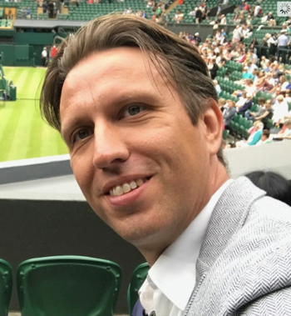
I have thoroughly enjoyed my work of the last 18 months on the Tennis Committee. For the last 6 months I have served as Tennis Captain. I would be proud to continue the work of Tennis Captain for the year ahead, to steward and develop our wonderful club.
I have been a member at WBC since 2009, and have enjoyed representing the club in competitive tennis at local, national and international levels. I have captained various league teams and have won the Club Championships in singles and doubles on multiple occasions. My tennis at the club has been highly enjoyable with a lot of proud moments!
My tennis background includes representing Great Britain at junior and veteran levels, plus playing county tennis for Avon and Warwickshire. I played tennis professionally as part of the LTA system in the mid-1990s, eventually securing a tennis scholarship to the University of Texas in Austin in the late 1990s, where I achieved “All-American” honours. I also earned a Cambridge “Blue” while studying for an MBA in 2003-04.
My business background includes over 20 years in the Technology sector, in a mix of FTSE-100 (Motorola, BT) and privately-held businesses in the Media Technology sector (Snell and Concurrent). I have held senior management positions over the last 15 years in operational, change management, marketing, sales, business development, and customer experience positions, and also served on multiple boards of privately-owned businesses. I now run my own business consultancy.
As a Tennis Committee member from 2015-17 I focused on strengthening LTA relationships and introducing a new-look Group Coaching course, with new Adult Group Coaching courses that have since become successful. Since becoming Tennis Captain in 2017, my focus has been to develop a new Tennis Constitution to lay the foundation for an efficient and effective Tennis Committee that will best serve the membership in future. The new constitution was adopted at the Tennis EGM in October 2017. In addition, I have been an advocate of sensible change management, responsible stewardship and development of the club’s finances, and driving towards an excellent and inclusive member experience for all members.
If re-elected I would focus on further development of the club’s infrastructure, continued development of coaching services for members, achievement in competitive and social tennis, and ensuring member satisfaction is as high as possible.
Paul Martin

Proposer: Steve Chidlow
Seconder: Geoff Sault

Membership, People & Welfare: Nominee - Graham Kensett
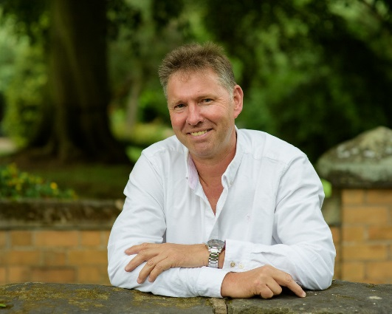
Originally from Sussex my wife and I moved to Leamington in 1994. As a graduate from Southampton University in Behavioural Sciences I lead a primary team within Guide Dogs providing services for people with sight loss.
Since 2014 I have served as a committee volunteer working with Tennis and Club Captains including our current captain Mike Rigby and tennis captain Paul Martin. These highly committed leaders display immense commitment and dedication into the strategy and planning which enables WBC to continually improve its services and facilities.
As an experienced lead volunteer at WBC. I have driven the development of our child protection responsibilities. We now have two welfare officers. Over the past year considerable improvements to our standards have been established, however further work is necessary in order to fully embed club welfare policies for our young people and adult members.
Through ongoing support of key volunteers, i have been instrumental in developing juniors and family membership promoting family sessions and activities for young people and parents. Early results are positive and indicate a demand which can positively impact upon our adult and junior membership. Through our investment in families and young people we will help secure the future of WBC.
I wish to continue to support our Club in moving forward together with one plan and one voice. We must place respect for people at the forefront of all we do. In working in unity we will maintain a culture of improvement where our members and services are consistently at the forefront of all we do.
Graham Kensett

Proposer: Don Clark
Seconder: James Francombe

Finance, Legal & Commercial: Nominee - Nick Peall
After serving for the last year as tennis section treasurer, I offer my nomination for re-election.
I have over 40 years’ business experience, latterly at a senior level, am currently Chair of a charity which supports needy, financially disadvantaged pensioners, and am a trustee director of one of the UK’s larger pension schemes.
My tennis experience includes representing Sussex in under 18 and men’s teams, and Warwickshire in the over 60’s team; managing the Sussex junior boys’ team in the 1980’s as well as representing Sussex LTA in respect of junior development in the LTA South East Region. I also served on West Worthing TC’s tennis committee, helping with the club becoming a county week centre and the organisation of an open tournament sponsored by the local building society. I became a member 4 years ago, following a move to Warwickshire.
In the last year as your tennis treasurer I have established regular, timely financial reporting for the tennis committee; improved the budgeting process and am in the process of establishing some insightful analysis of income and expenditure.
With re-election I would continue, with fellow committee members, to develop our financial management; seek opportunities to increase income from various sources, whilst closely managing expenditures; and ensure any significant development proposals are properly researched, costed and member consultation sought before any decision to proceed is made.
I will continue to work for the benefit of all members.
Nick Peall

Proposer: Owen Watson
Seconder: Paul Martin

Tennis Marketing & PR: Nominee - Graham Harrington
I have been a member of the tennis section of Warwick Boat Club since 1997. I played league tennis, mainly for the second team, for many years and have been an active social player throughout my time at the club.
At work, I have been involved in marketing and sales roles for some forty years. Since 1991 I have been a director of a marketing and design agency. Parallel Creative has a team of eight working with a diverse client base delivering all manner of marketing collateral and advertising services. This includes both conventional and digital platforms.
I have been on the tennis committee for ten years. I am also on the club marketing committee. I believe Warwick Boat Club to be special in many ways and am pleased to be able to help members get the most from what it offers, and to introduce prospective members to the club. Provided the membership remains at healthy levels the club will continue to thrive.
Graham Harrington

Proposer: Geoff Prince
Seconder: Paul Martin

Tennis Facilities & Development: Nominee - Geoff Prince
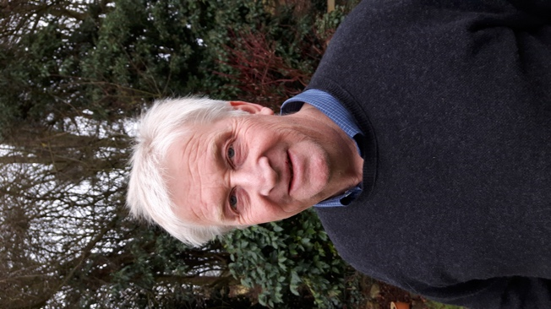
The next 2-3 years will be a very exciting and challenging period in the history of Warwick Boat Club as it evolves its long-term vision, development and investment plan to ensure that the Club will have even better facilities where we can enjoy playing our favourite sports and meeting our fellow members. As a member of the Tennis Committee (since 2016) I have attended a number of working group meetings over the past 12 months under the umbrella of the Club Captain where we have been drawing together ideas form the different sections and assessing the ‘art of the possible’ before presenting our plans to members and also to the wider community including local Councillors, Warwick District Council, local schools, other stakeholders and funding organisations. I have over 40 years experience of coordinating complex development projects often in sensitive and attractive locations such as we enjoy at WBC, where success depends on ensuring support from the membership as well as the wider stakeholders. As a regular playing predominantly social member with good links to other sections I believe I have the experience, eyes and ears to represent the interests of the Tennis section in evolving these plans, but also ensuring that we do not forget the need to maintain first class facilities in the short term.
I therefore seek your vote to be your Facilities and Development representative on the Tennis Committee.
Geoff Prince

Proposer: Paul Martin
Seconder: Owen Watson

Team Tennis: Nominee 1 - Don Clark
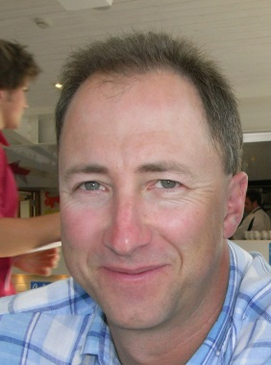
I have lived in Warwick for almost 20 years now and have been an active member at Warwick Boat Club for 8 years.
On a work front I trained as a Pharmacist and worked my way up the career ladder with a large national retailer.
I have been the captain of the 5th team tennis for WBC for the past two years earning a promotion in the first year. I have a strong network of contacts at the club both through the team tennis, social tennis and men’s group tennis which I set up 7 years ago. I was also the instigator and co-organiser of the largest charity event ever run by the club when we played a 24-hour tennisthon and raised £6500 for Myton Hospice.
I have proven skills as a planner and organiser and I would look to incorporate those into developing team tennis within the club in partnership with the tennis captains and team captains.
I truly believe we have the best tennis club in the land and want to see it flourish well into the future.
Don Clark

Proposer: Graham Kensett
Seconder: Steve Chidlow

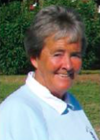
Team Tennis: Nominee 2 - Jackie Robinson
The next 2-3 years will be a very exciting and challenging period in the history of Warwick Boat Club as I wish to stand for the post of “Team Tennis”.
In addition to being a coach at the club for the past 30 years, I have also served on the tennis committee for several years. I have also been Ladies Captain and captain of the Ist team in the Ladies Premier division. The Boat Club asked me to stand for election to the Coventry League Committee on which I have now been a member for the past 3 years. I am also an elected Councillor of the Seniors Tennis GB with special responsibility for running the Inter-clubs events. To date we have 17 events and over 400 teams involved.
As a player I have been fortunate enough to be selected for the GB team in the World Championships at the 45/50/55/60/65 age groups. I have played for Warwickshire Veterans since reaching the age of 40 having been a Worcestershire player until then, and am pleased to say the Warks 65 team of which I am captain have qualified for the finals against Surrey in December. WBC Seniors ladies have also in the past won the European O50 and 60 titles, and won several National Age Group titles.
I would hope you would feel that this proves that I am “a bit of an organizer” and so feel more than capable of taking on the role of “Team Tennis” The role as I see it involves working with all the captains to ensure we have successful teams throughout and to encourage as many people as possible to get involved.
To my mind WBC is one of the foremost clubs in the Country, be it its location, standard of play and general enthusiasm of all its members both Senior and Junior, and I would be privileged to serve on the Tennis Committee.
I recently retired as President of England Squash and am now an elected member of the European Squash Federation.
Jackie Robinson

Proposer: Jenny Waggott
Seconder: Susie Rowe

Social Tennis: Nominee 1 - Daryl Howe
Firstly I think that Social tennis member of the committee is a key role. The vast majority of the tennis membership are social players and they need representing on the committee. Not all of us were born with Marcus Willis’s talent but we are important! Most of us are just here for exercise, fun and relaxation.
I have been a member of the WBC for two and a half years. Previously I have played club tennis at Henley in Arden and also briefly been a member of Stratford upon Avon tennis club.
One of the most attractive aspects of WBC which differentiates it from other clubs, is it is genuinely welcoming and the social side seems to really work. The success of mix-ins is a key part of this strategy. Since joining I have been to the vast majority of Wednesday night and Saturday mix-ins and occasionally Sunday mornings. I have done my fair share of cooking on Wednesday evenings (cooking for 25 has its challenges!), been to most club social functions, been on an Active Away holiday (with other WBC members) and my youngest son Alex is 22 is also a club member. In fact the WBC and the friends I have made through the club, have become a key part of my and Anita my other half’s, social life.
I fully retired last year and feel strongly about giving back, making a difference and helping others. I now have the time to devote to this. I am passionate about openness, inclusivity, equal opportunity in every aspect, I believe that WBC reflect those values. I am also a ‘people person’ and I would like to think I have good communication and people skills.
In my working life I am a successful business man. My career experience is at Director level in General Management, IT and Human Resources and spans both major plc’s (Cadbury Schweppes and ITnet) and in small businesses, largely in the Computer Services sector. I have had lots of good customer service experience, am action orientated and well organised.
In a nutshell, I think volunteering for the tennis committee, being positive and enthusiastic about the club, making the effort to contribute, is a genuine way for me to help others.
Daryl Howe

Proposer: Jane Robbins
Seconder: Phil Allen

Social Tennis: Nominee 2 - Trix Law

I have been a member of Warwick Boat Club for 27 years, playing at least twice a week. I regularly attend the Ladies’ Coaching session, organise my group during holiday times and play in the Tuesday mix-in. I find this participation very important as it gives me direct contact with other members of all ages and abilities, including new and established members.
I was elected to the Tennis Committee in November 2016 to represent the interests of day time members participating in coaching sessions and playing social tennis.
Since being elected:
- I have channelled communications from members to the Committee and I believe they would agree that I am hard-working, conscientious and, above all, approachable. If re-elected, I would continue to do this, as well as exploring ways to enhance our members’ playing experience.
- I am a point of contact for new members. We regularly have new members joining our Tennis section. On seeing a new face at the club, I introduce myself as a member of the Tennis Committee and tell them if there is anything they would like to know, or I can be of assistance in any way, they should feel free to contact me.
- I have deputised for Gavin Henderson on several occasions at the Tuesday mix-in.
- I participate at Open Evenings, willingly giving my time to try to encourage new members.
- I take members’ requests and concerns to the Tennis Committee. Recently, as a result of such a request, I obtained approval for an additional mix-in on a Friday afternoon. We have been running it on a trial basis for a few months and the session is proving very popular and a welcome addition to the mix-in programme. I recently volunteered to supervise Friday mix-in to monitor its success for the Committee. The feedback has been very positive, with a wide variety of abilities attending and members commenting that it has developed its own, albeit very competitive, atmosphere.
- I organised MyCourts booking refunds of £1,062.00 to 93 tennis members.
I look forward to continuing in this very important role.
Trix Law

Proposer: Philip Purcell
Seconder: Sue Woodward

